|  |  |  |
| --- | --- | --- |
| **Module** | **Topics** | **L hrs** |
| 1 | **Introduction to computer architecture:-**Introduction to computer systems - Overview of Organization and Architecture – Components, Registers and register files, Connections-– Von Neumann machine (IAS Machine) – Architecture – Communication between components | 4 |
| 2 | **Fundamentals of Computer Architecture**:-Introduction to ISA (Instruction Set Architecture): Instruction formats - Instruction types - Addressing modes - Instruction cycle – Introduction to Assembly Language Programming. | 6 |
| 3 | **Data Representation And Computer Arithmetic:-**Data Representation – Introduction to Fixed point representation of numbers - Floating point representation of numbers (IEEE standard representation) - Algorithms for fixed point arithmetic operations: Addition, Subtraction, Multiplication (Booth’s Algorithm), Division - Representation of non-numeric data (character codes). | 9 |
| 4 | **Memory System Organization & Architecture:-**Memory systems hierarchy - Main memory organization – Byte ordering - Memory interleaving - Memory characteristics - Cache memories: Introduction - Parameters of Cache memory - Address mapping – Read and write policies - Cache Coherence - Virtual memory systems- TLB- Page replacement Algorithms. | 10 |
| 5 | **Interfacing and Communication I/O fundamentals:-**I/O fundamentals: I/O Modules, I/O mapped I/O and Memory Mapped I/O - Introduction to I/O techniques: Programmed I/O, Interrupt-driven I/O, DMA - Interrupt structures: Interrupt cycle, Subroutine call and return mechanisms - Bus System: Synchronous and asynchronous buses, Bus Arbitration. | 7 |
| 6 | **Device Subsystems:-**External storage systems - Organization and structure of disk drives: Electronic, Magnetic and optical technologies - RAID Levels - I/O Performance | 4 |
| 7 | **Performance Enhancements:-**Classification of models - Flynn’s taxonomy of parallel machine models ( SISD, SIMD, MISD, MIMD)- Introduction to data path - Introduction to Pipelining - Pipelined data path - Introduction to hazards. | 4 |
| 8 | **Recent Trends** | 1 |

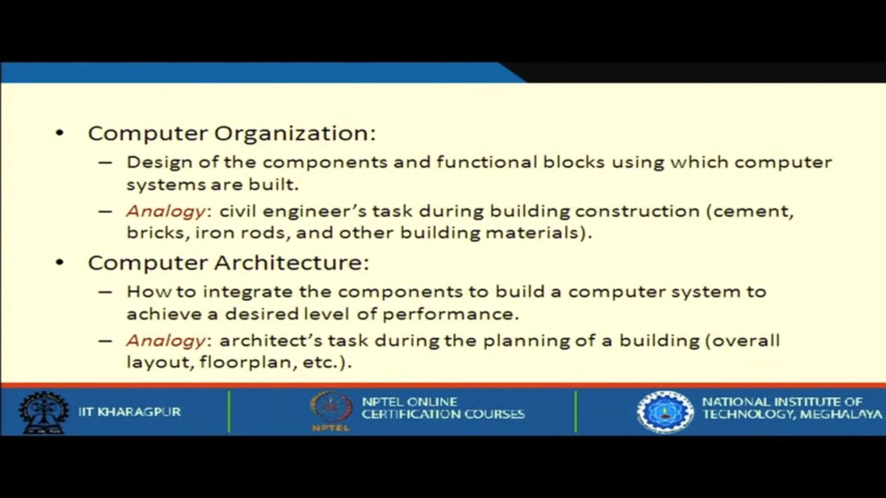

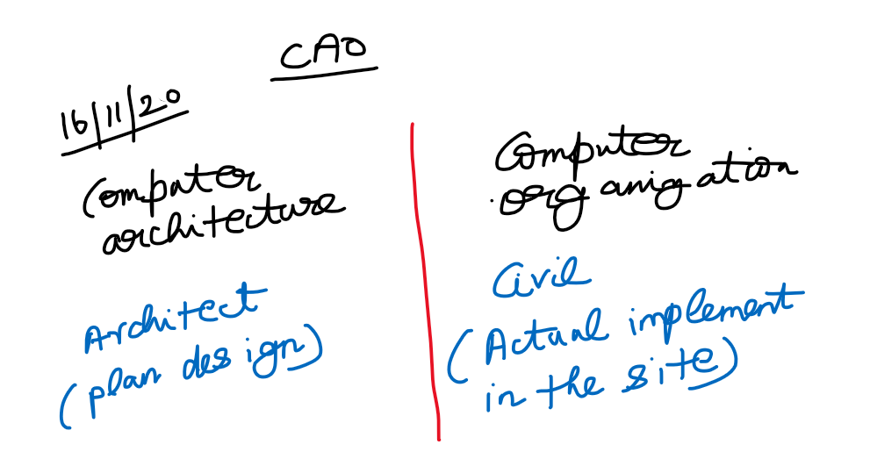

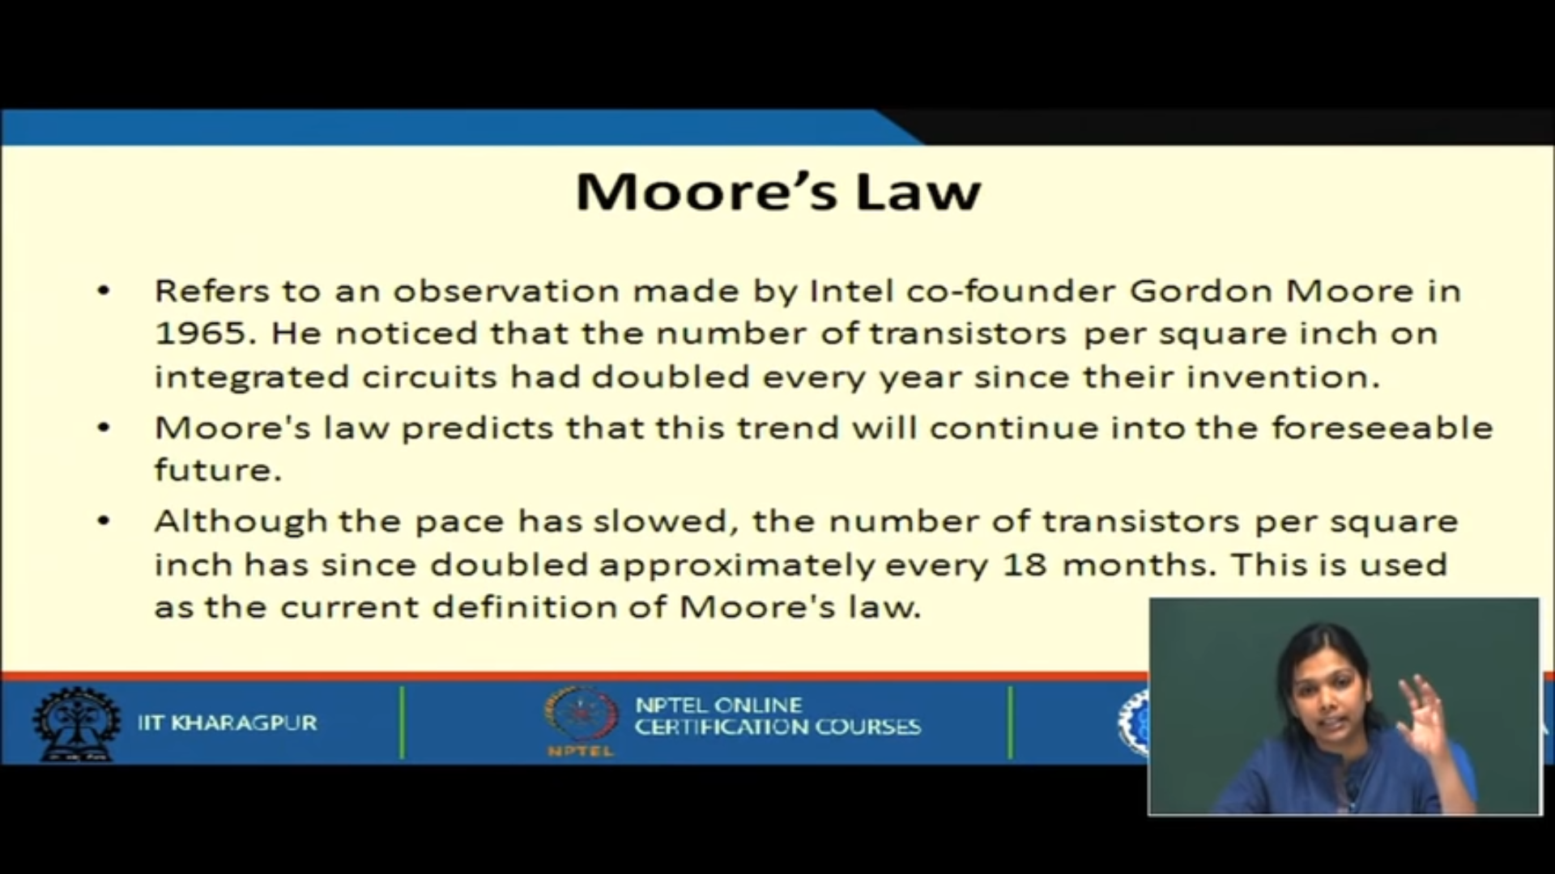

**Von-Neuman Architecture**

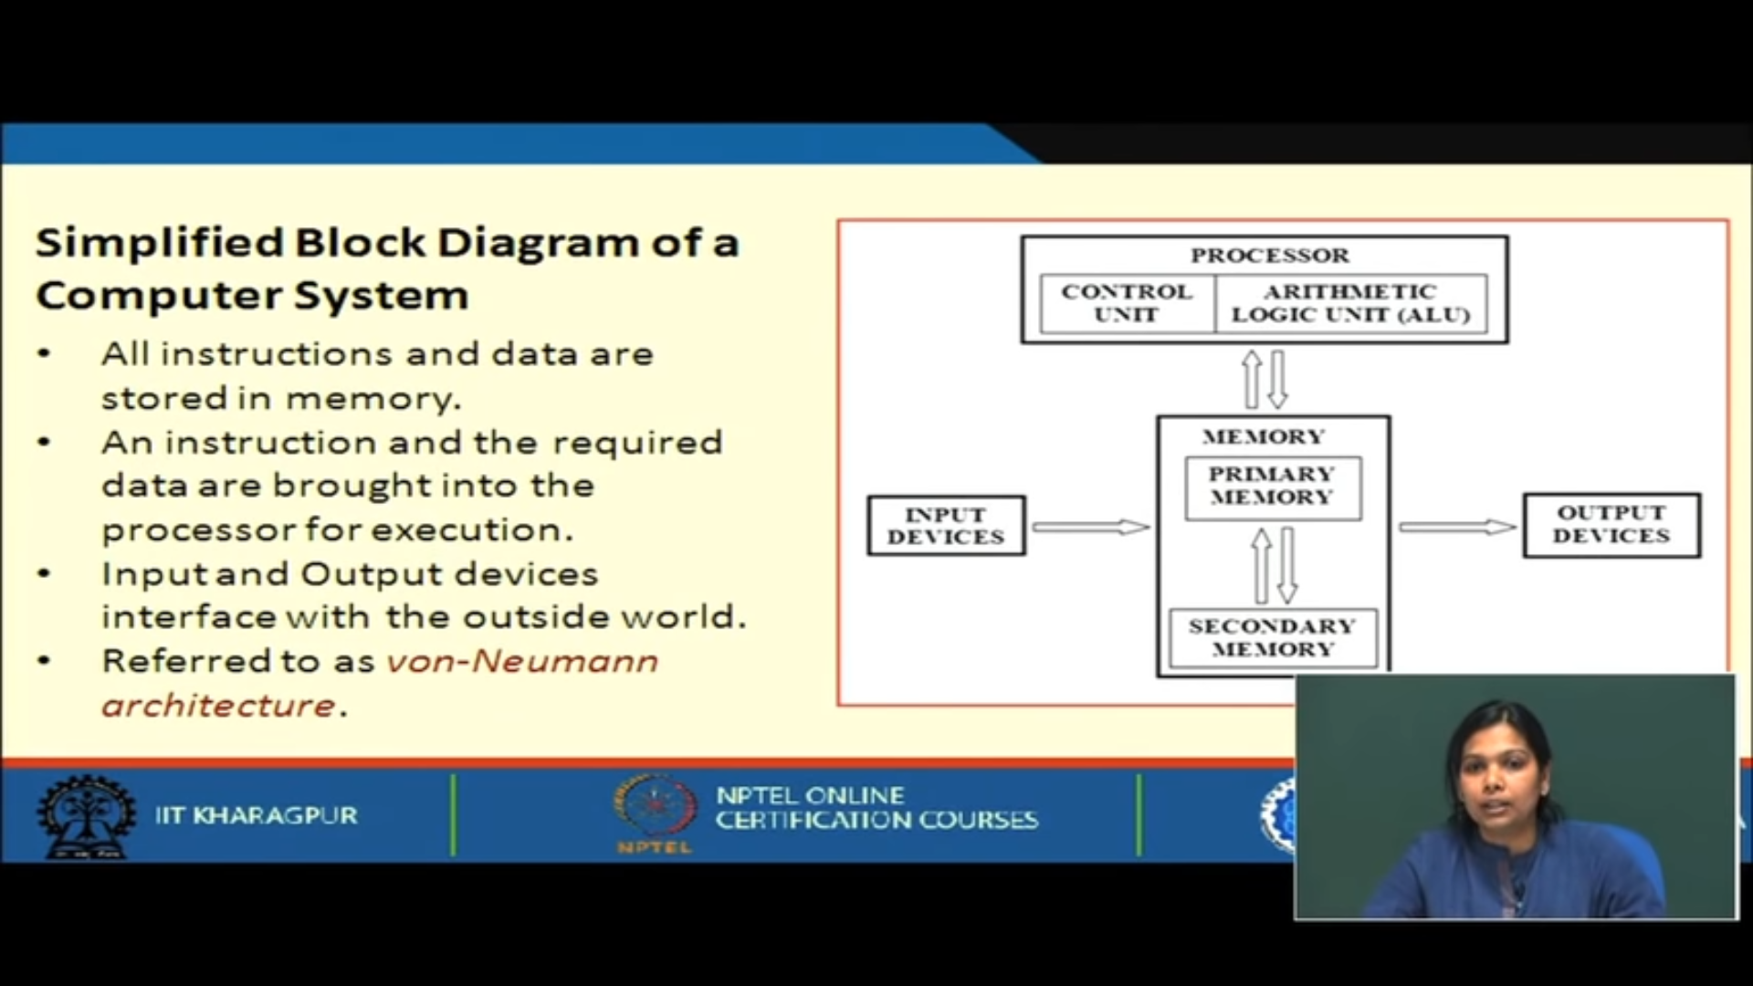

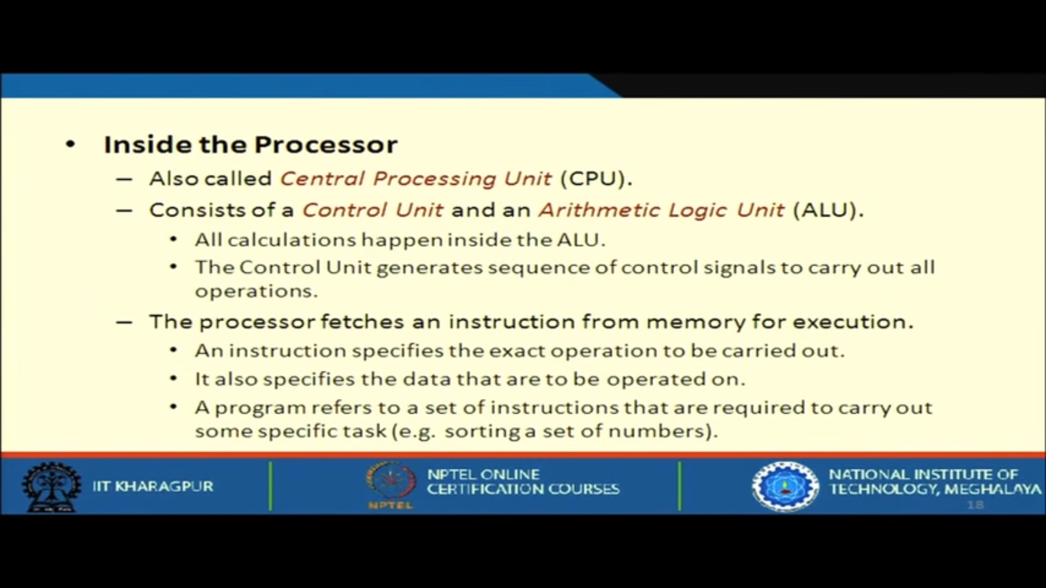

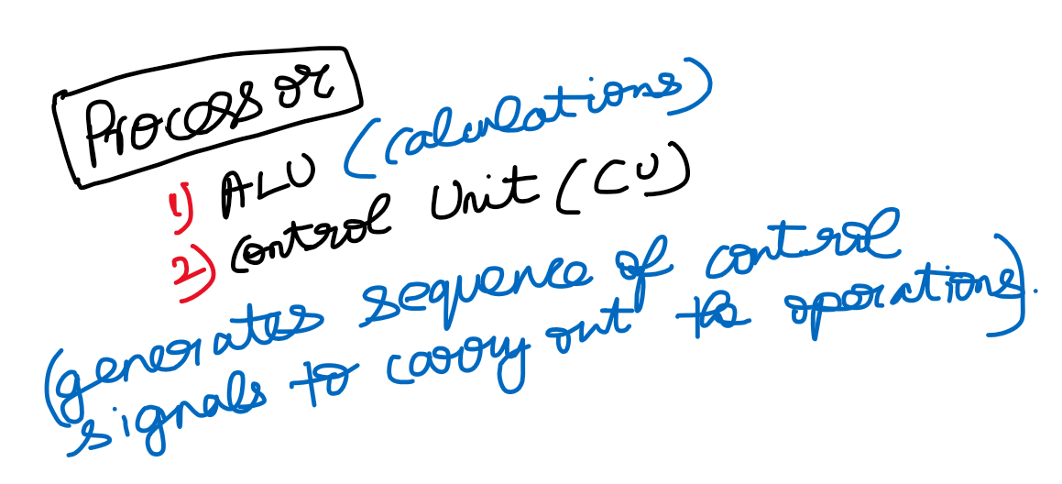



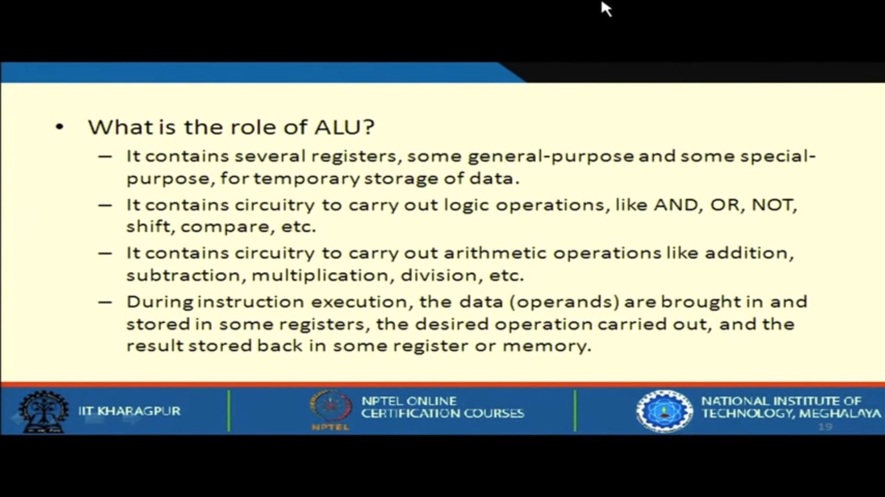



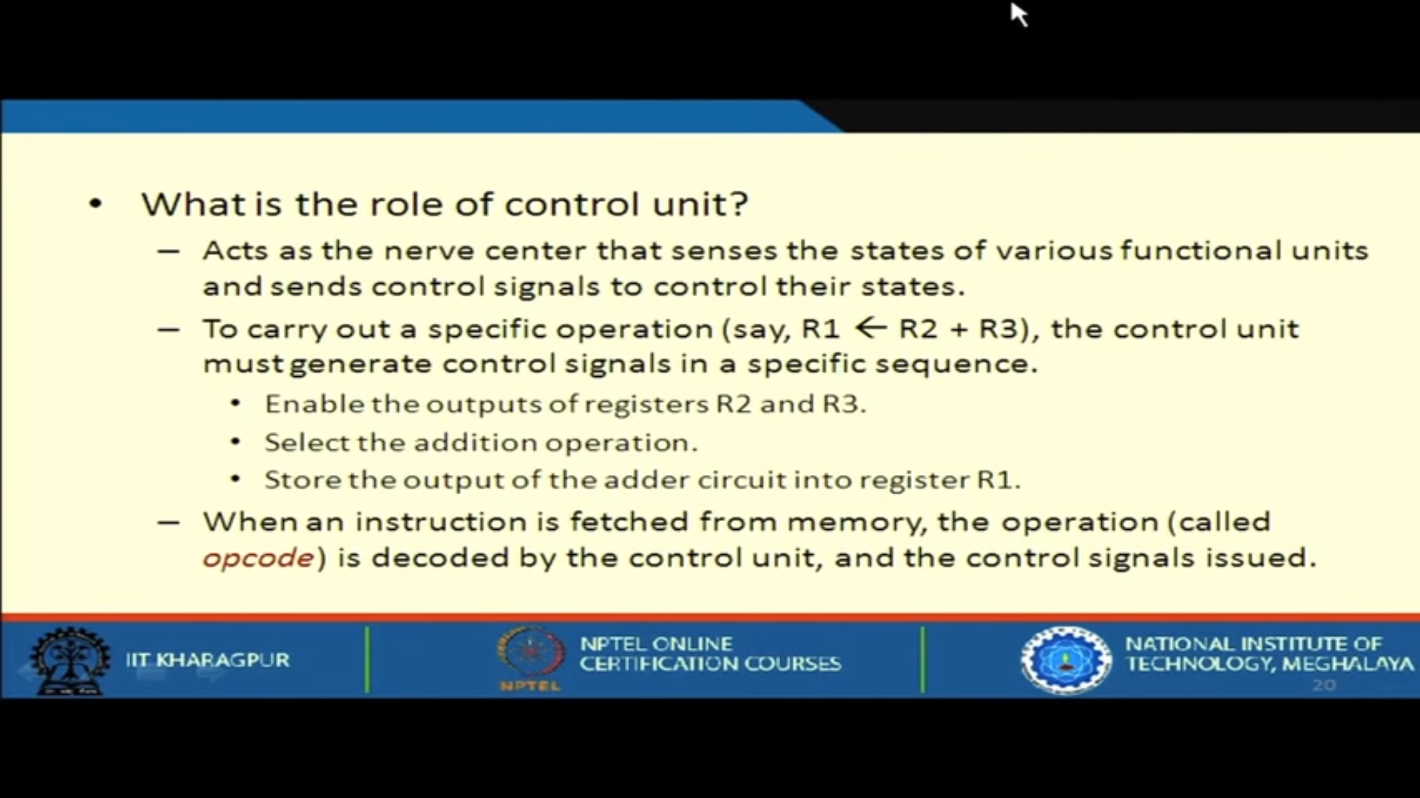

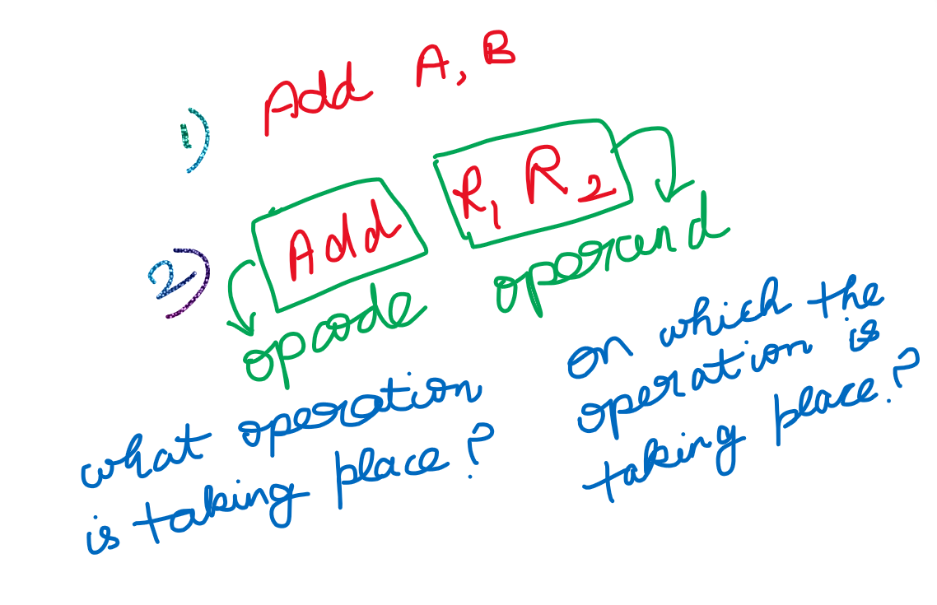

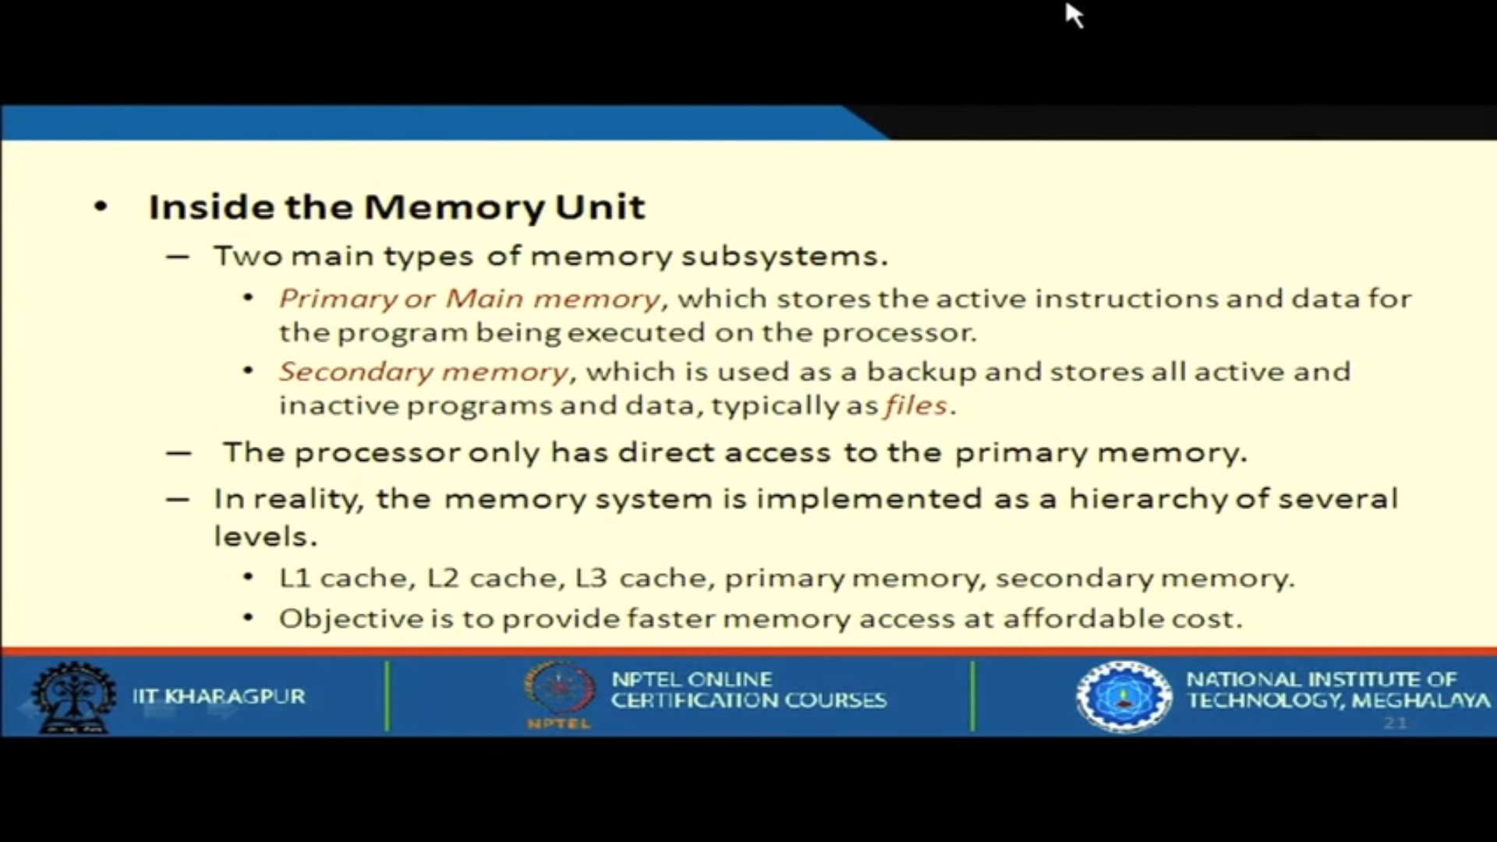

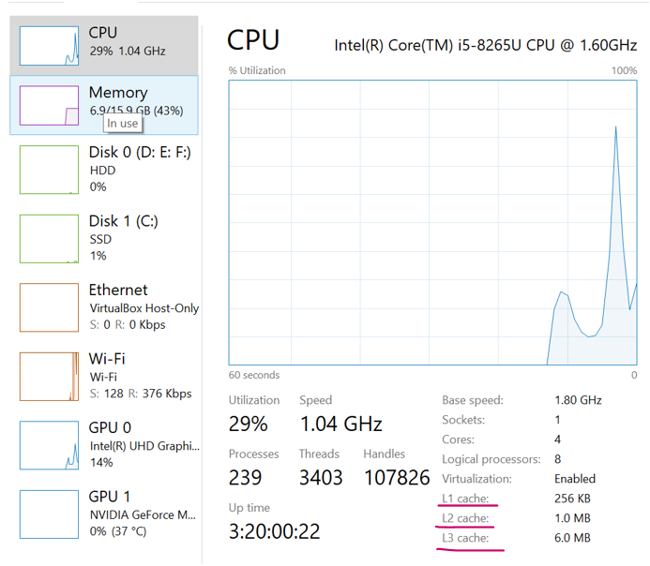

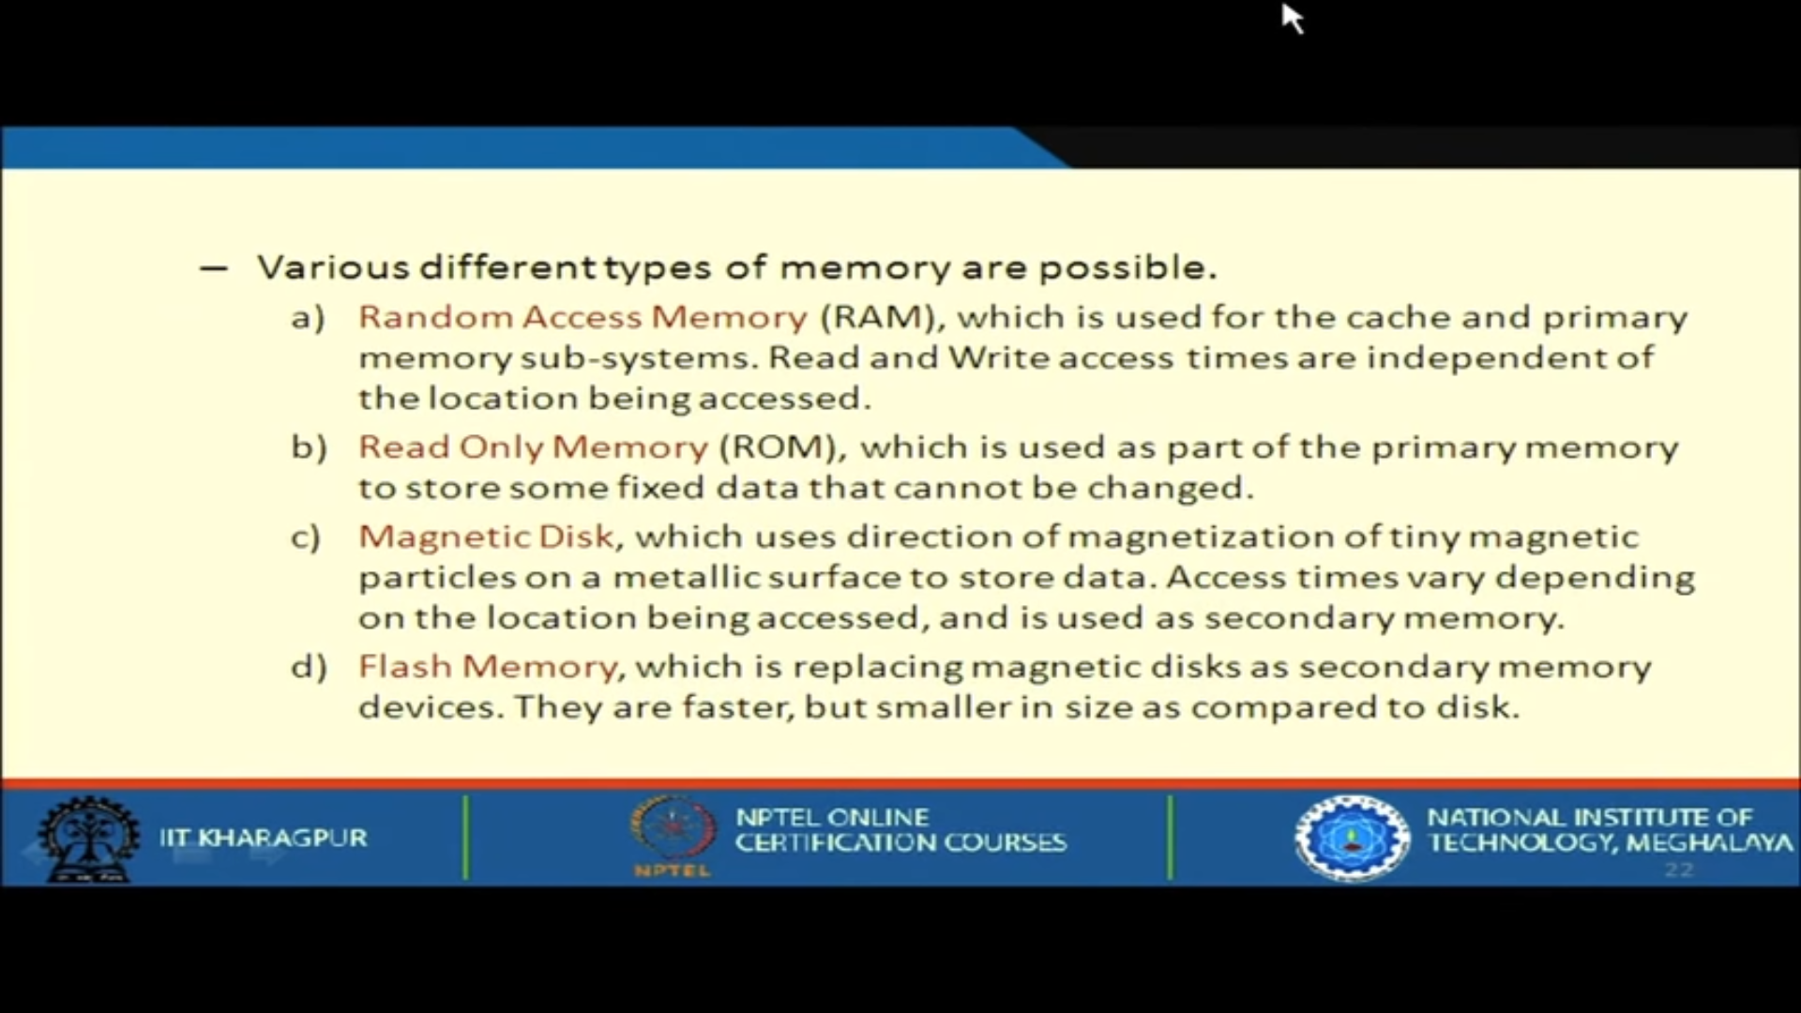

Flash memory 🡪 It is a solid state technology (i.e no moving parts) which uses integrated circuits. When **flash** technology is used for enterprise **storage**, the term **flash drive** or **flash** array is often used interchangeably with solid-state **drive** (**SSD**).

